Insight:

The final report looks like this

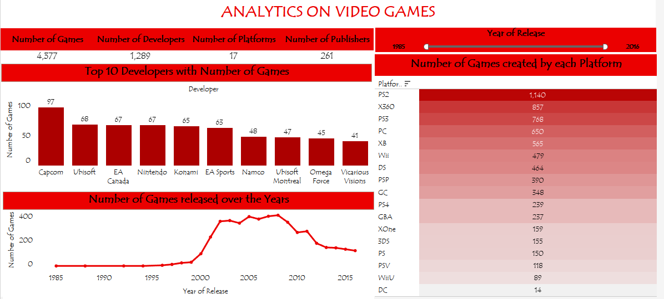

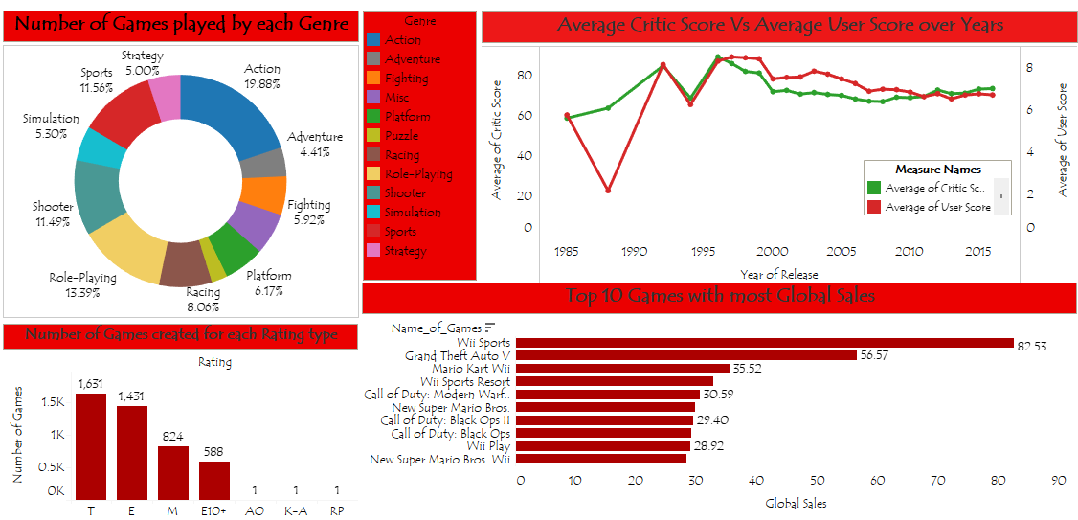

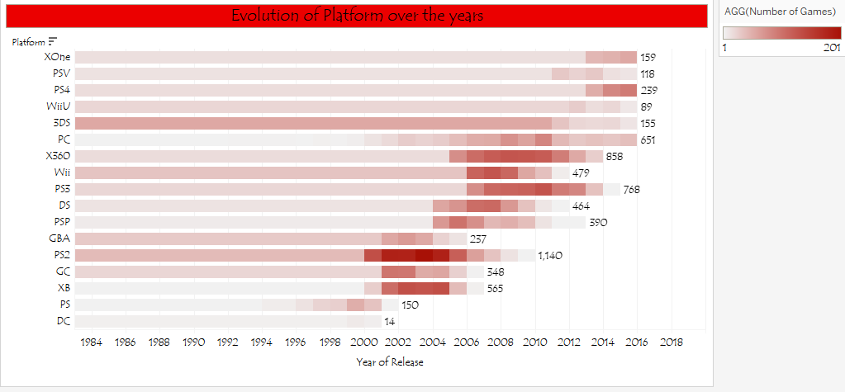

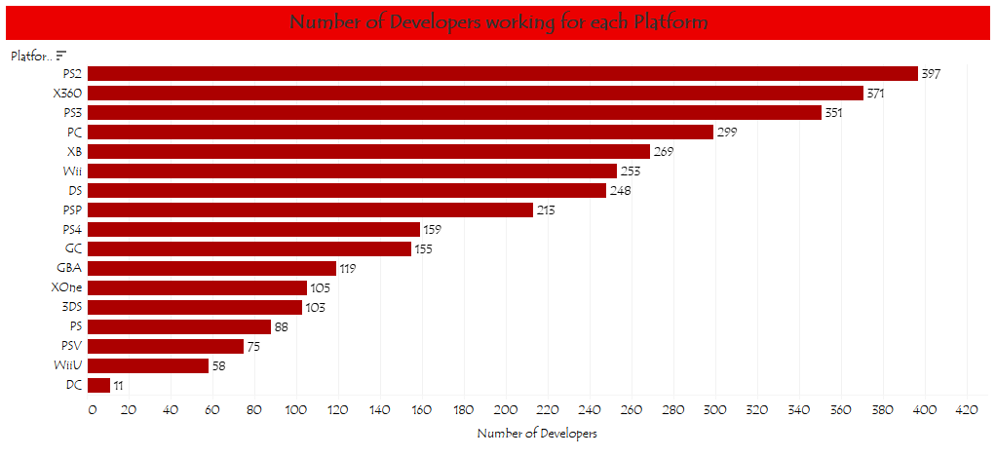

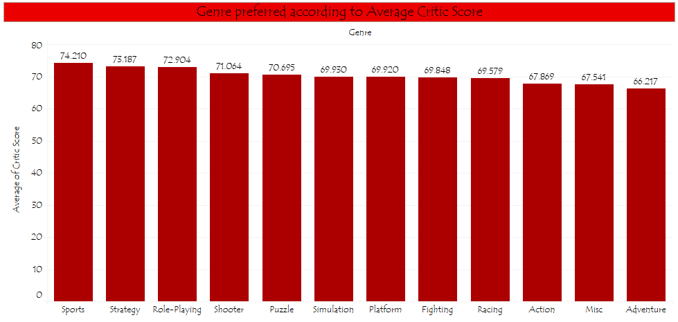

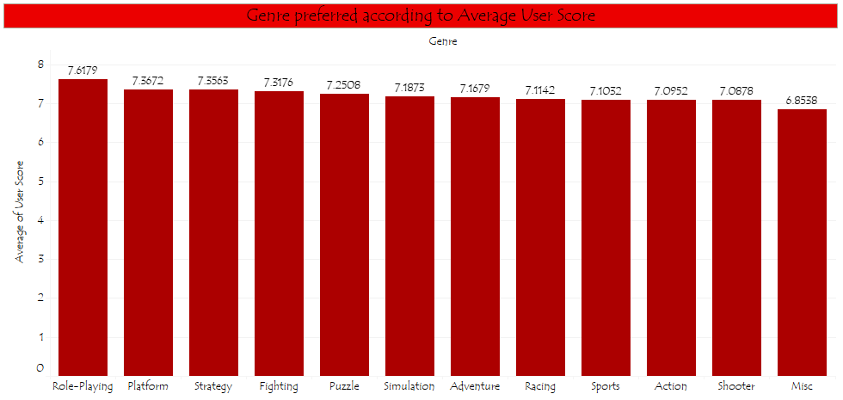

I have found that:

* Most of the games are created by PS2 and X360
* Over the years Average Critic’s Score is bit more than Average User’s Score
* According to number of games created over the years, the era of evolution is between 2000 and 2008
* PS2 and X360 has most number of games created with most number of developers working for them yet over the years PC and PS4 has run the longest in creating games till 2016
* Top 10 Developers(out of 1289) have created more than 47% of the total created games
* Over the years PS and DC platform disappeared
* Action and Role-Playing are the two most genre games created
* Most number of games were created for Teen and Everyone in terms of ESRB Rating
* Wii Sports and Grand Theft Auto V are the most sold games globally
* According to Average Critic’s score most preferred genre is Sports(74.21) and According to Average User’s Score most preferred genre is Role-Playing(7.61)